AS-EACS-2025-00748
Title:
Cost-effectiveness of lenacapavir versus tenofovir disoproxil fumarate plus emtricitabine for pre-exposure prophylaxis to prevent HIV-1 transmission in gay, bisexual and other men who have sex in a European country
Preferred presentation type:
Oral presentation
Authors:
P. Wikman-Jorgensen ^{1, 2}, C. Iniesta ^{3, 4}, M. Ruiz-Algueró ^{4, 5}, F. Pulido ⁵, J.A. Perez-Molina ^{4, 6}, J. Llenas-García ^{2, 4, 8}
¹Hospital General Universitario de Elda-FISABIO, Infectious Diseases-Internal Medicine, Elda, Spain, ²Universidad Miguel Hernández, Clinical Medicine, Elche, Spain, ³Spanish Interdisciplinary AIDS Society (SEISIDA)., Madrid, Spain, , CIBER de Enfermedades Infecciosas (CIBERINFEC), ⁴Instituto de Salud Carlos III, Madrid, Spain, ⁵University of British Columbia, Faculty of Medicine,, Vancouver, Canada, ⁶Institute for Healthcare Research Hospital 12 de Octubre (imas12), Universidad Complutense de Madrid, HIV Unit, Madrid, Spain, ⁷University Hospital Ramon y Cajal, 6. Referral Centre for Tropical Diseases. Infectious Diseases Department., Madrid, Spain, ⁸Hospital Vega Baja-FISABIO, Infectious Diseases-Internal Medicine, Orihuela, Spain
Con todas las filiaciones que hay yo te apunto las mías aparte para aclararte:
⁷ Referral Centre for Tropical Diseases. Infectious Diseases Department, University Hospital Ramon y Cajal, Madrid, Spain
CIBER de Enfermedades Infecciosas (CIBERINFEC), ⁴Instituto de Salud Carlos III, Madrid, Spain

Purpose: *
Lenacapavir (LEN) has proven to be superior to, tenofovir disoproxil fumarate plus emtricitabine (TDF/FTC), as pre-exposure prophylaxis (PrEP) for key populations at high risk of HIV acquisition. This study aims to compare the cost-effectiveness of currently approved PrEP in Spain, with daily TDF/FTC, in gay, bisexual and other men who have sex with men (GBMSM) versus the newer alternative with subcutaneous LEN every 6 months.
Alternativa un poco más corta: The study assessed which PrEP strategy was more cost-effective for gay, bisexual and other men who have sex with men (GBMSM) in Spain: daily oral TDF/FTC or subcutaneous LEN administered every six months.

Method: *
We fitted a dynamic compartmentalised Markov model that represents the dynamics of HIV-1 transmission in GBMSM in Spain. The model was calibrated to replicate the epidemiological data from 2019 to 2023. We used the perspective of the national health system and applied a 20-year time horizon. Quality-adjusted life years (QALY) were the health outcome variable, and the cost was accounted for in 2023 Euros (€). Our outcome variable was the incremental cost-effectiveness ratio (ICER). We used the 2023 gross domestic product per capita of Spain (€31,339) as the willingness-to-pay (WTP) threshold.
Results: *
In the TDF/FTC arm the simulation yielded 8,546,030 QALYs at a cost of €8,457,028,025 for the next 20 years, with an average cost-effectiveness ratio of €989.58 per QALY. If LEN were used instead of TDF/FTC, it would cost €47,062,063,906 (an increase of €38,605,035,881) producing a total of 9,030,933 QALYs (i.e. an increase of 484,903.7 QALYs), yielding an ICER of 79,613.82 €/QALYs. Adherence and number of GBMSM living with HIV were the main variables affecting the ICER in a deterministic sensitivity analysis. However, it did not come close to WTP. A probabilistic sensitivity analysis was also undertaken where the cost was iterated down to € 4,320 per six-month dose yielding a probability of cost-effectiveness of 93.6%.
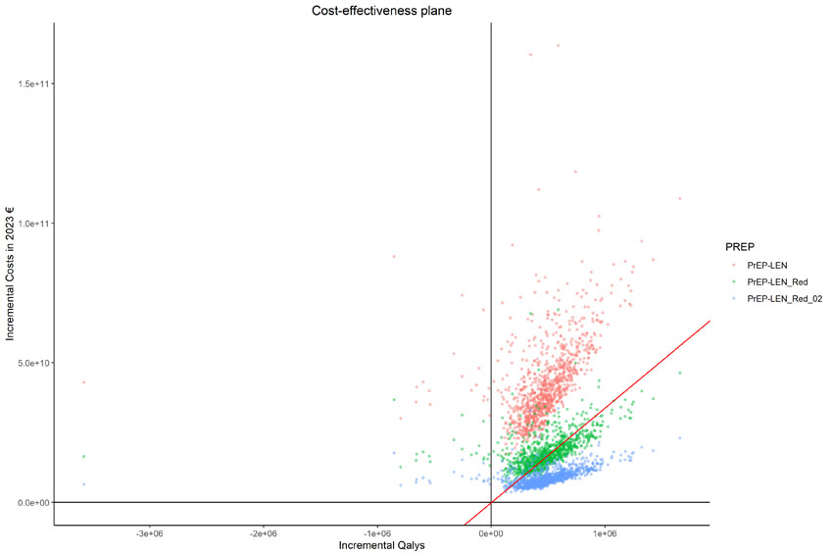

Alt text: Scatter plot titled "Cost-effectiveness plane" showing incremental costs in 2023 euros on the y-axis and incremental QALYs on the x-axis for three PrEP strategies: PrEP-LEN (red), PrEP-LEN_Red (green), and PrEP-LEN_Red_02 (blue), representing different LEN prices.. Each point represents a simulation result. A red diagonal line indicates a willingness-to-pay threshold. Most points lie in the upper-right quadrant, suggesting increased cost and effectiveness, with PrEP-LEN_Red_02 generally appearing to be more cost-effective than the others.
Si es posible llamaría a cada categoría de otra manera para que se entendiera mejor. Si son precios algo como LEN_Scenario01, LEN_Scenario02 y LEN_Scenario03. Añadiría en el gráfico en texto la áreas de coste efectividad y las que no lo son.

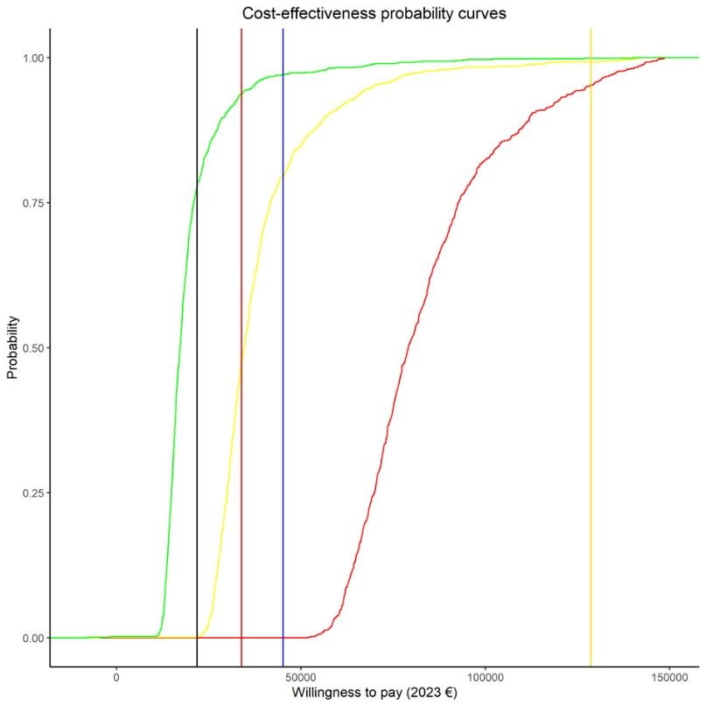

Alt text: Line graph titled "Cost-effectiveness probability curves" showing the probability that a PrEP strategy is cost-effective across a range of willingness-to-pay (WTP) thresholds in 2023 euros. Three sigmoidal curves represent different drug costs: red (€21,088.5), yellow (€8,880), and green (€4,320). Four vertical lines mark GDP per capita values: black (Croatia), red (Spain), blue (Euro Zone), and yellow (Luxembourg). The green curve (lowest drug cost) reaches high probability of cost-effectiveness at the lowest WTP,. This trend indicates that the cost-effectiveness of the strategy improves as the drug price decreases.

Conclusions: *
Twice-yearly subcutaneous LEN could be cost-effective as Prep for GBMSM in Spain at a threshold of €4,320 per six-month dose.
Abstract word count:
Words: 300 of 300
Tables: 0 of 3
Table rows: 0 of 30
Images: 2 of 2

